

**PROJECT REPORT**

**Escrow Payments and Online Marketplace**

[ Syed Wali Mohsin Naqvi(Group Leader)] - [k224550]

[Syed Ghalib Hussain Zaidi] - [k224536]

[Hafiz Syed Muhammad Rayyan Alam] - [k224373]

___________________________________________________________________

STUDENT NAME ROLL NO

12-12-2022

SIGNATURE & DATE

**NATIONAL UNIVERSITY OF COMPUTER AND EMERGING SCIENCES (NUCES), KARACHI**

**Project Overview: Online Marketplace**

Our Online Marketplace is poised to redefine the landscape of e-commerce, offering a sophisticated and user-friendly platform for the exchange of goods. Tailored to accommodate a diverse array of products, sellers can present their offerings with precision while buyers experience an intuitive and comprehensive interface.

**Key Features:**

1. **Intuitive Navigation:** Users will benefit from a seamless and user-friendly interface, ensuring ease of navigation for a diverse user base.

2. **Comprehensive Product Listings:** Sellers are empowered to present their products with meticulous detail, including high-quality images, specifications, and detailed descriptions.

3. **Advanced Search and Filtering:** Robust search and filtering options, encompassing categories, price ranges, and keyword searches, provide buyers with a streamlined shopping experience.

4. **Secure Payment Integration:** Our platform prioritizes trust and security, with a seamless payment gateway facilitating secure transactions between buyers and sellers.

5. **Vendor rating and Review System:** Transparency is paramount. Our platform incorporates a vendor rating and review system, allowing users to make informed decisions based on the experiences of their peers.

**Methodology and flow of program:**

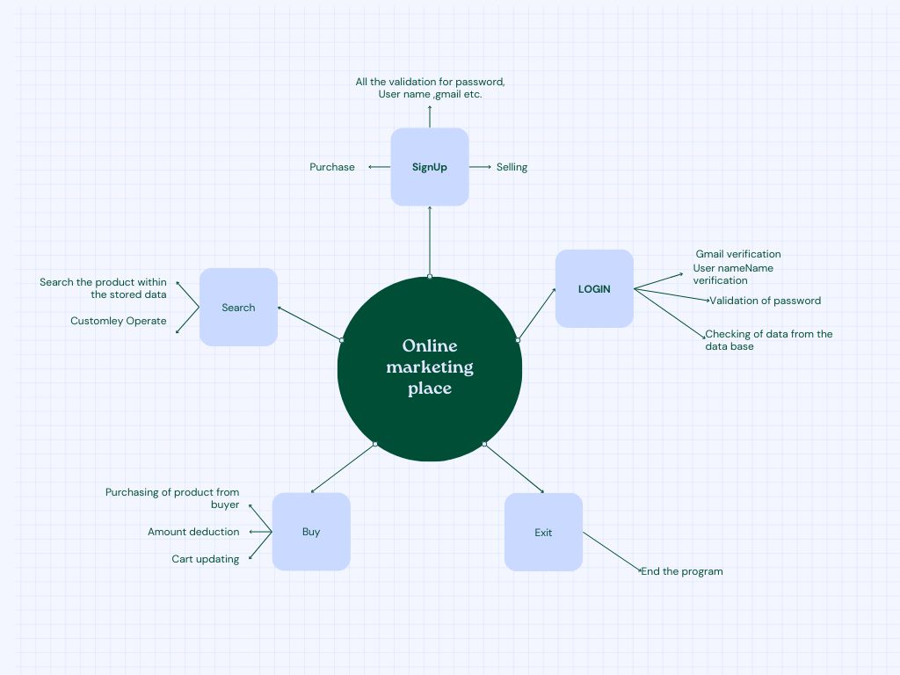

1. User Registration and Authentication:
   1. Users register on the platform using personal information and credentials.
   2. Authentication ensures secure access to the marketplace.
2. Product Listing:
   1. Sellers create listings for their products, including details such as title, description, price, and images.
   2. Listings are stored in the database.
3. Search and Browse:
   1. Buyers can search for products using keywords, categories, or filters.
   2. The system retrieves relevant listings from the database.
4. Product Detail Page:
   1. Buyers view detailed information about a product on its dedicated page.
   2. They can initiate actions such as adding to cart or contacting the seller.
5. Add to Cart:
   1. Buyers add desired products to their shopping cart for a consolidated checkout experience.
6. Checkout and Payment:
   1. Buyers proceed to checkout, where they confirm their order and enter payment details.
   2. Payment processing is facilitated through a secure payment gateway.
7. Order Confirmation:
   1. Users receive confirmation of their order, including details and expected delivery dates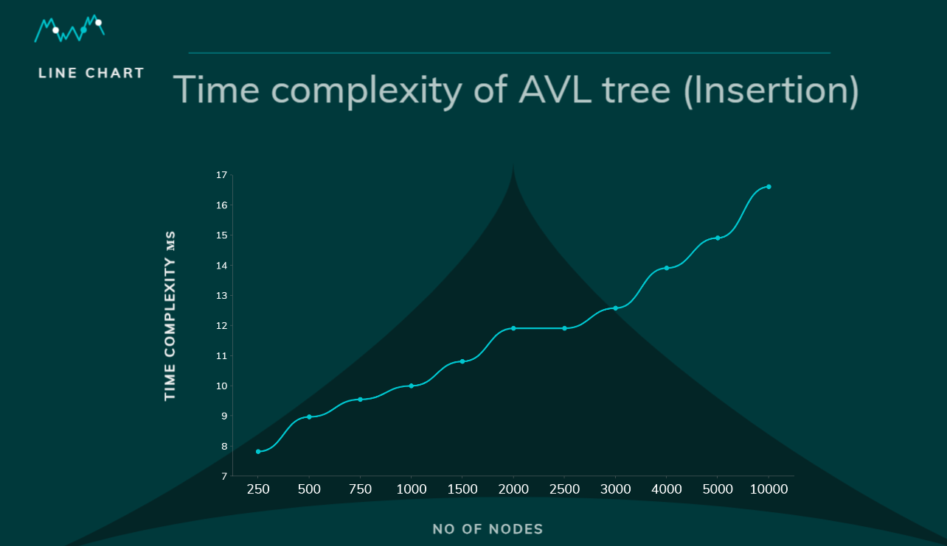

**About the data structure:**

In our online marketplace, data structures like hash tables, arrays, and trees optimize efficiency. Hash tables secure credentials, arrays manage craft listings, and Max heaps categorize crafts. Tree or binary search trees power searches. Secure hashing safeguards payments, queues facilitate messaging ensures overall system efficiency. These streamlined data structures form the foundation for scalability and optimal performance.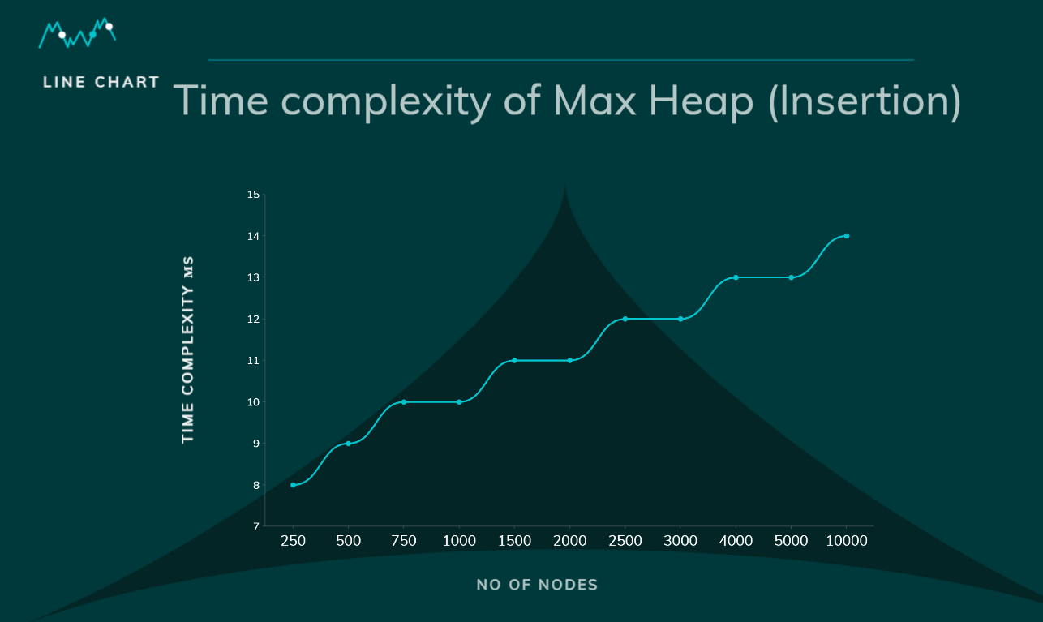

**Conclusion:** In summary, our Online Marketplace redefines e-commerce with a user-centric approach, innovative features, and a robust backend. Carefully chosen data structures ensure efficiency and scalability, challenging norms with a real-time negotiation model. The platform provides users unprecedented control, departing from fixed pricing for a dynamic and responsive shopping experience

Thankyou

Best Regards